We used mostly the GPS in conjunction with our application. The main example of the functionality of this was in the GPSManager class, which can be viewed on GitHub [here](https://github.com/RShankar/Empower-App-WhatsUp-Fall-2014/blob/master/Source/app/src/main/java/edu/fau/whatsup/Managers/GPSManager.java). Essentially this class operates as a singleton that acts as the gateway between the rest of the application and the main application’s logic. The GPS and location data is used in all facets of the application and is responsible for finding the current location, as well as sending off to flurry so we can analyze usages. Below is a screenshot of our map, populated.

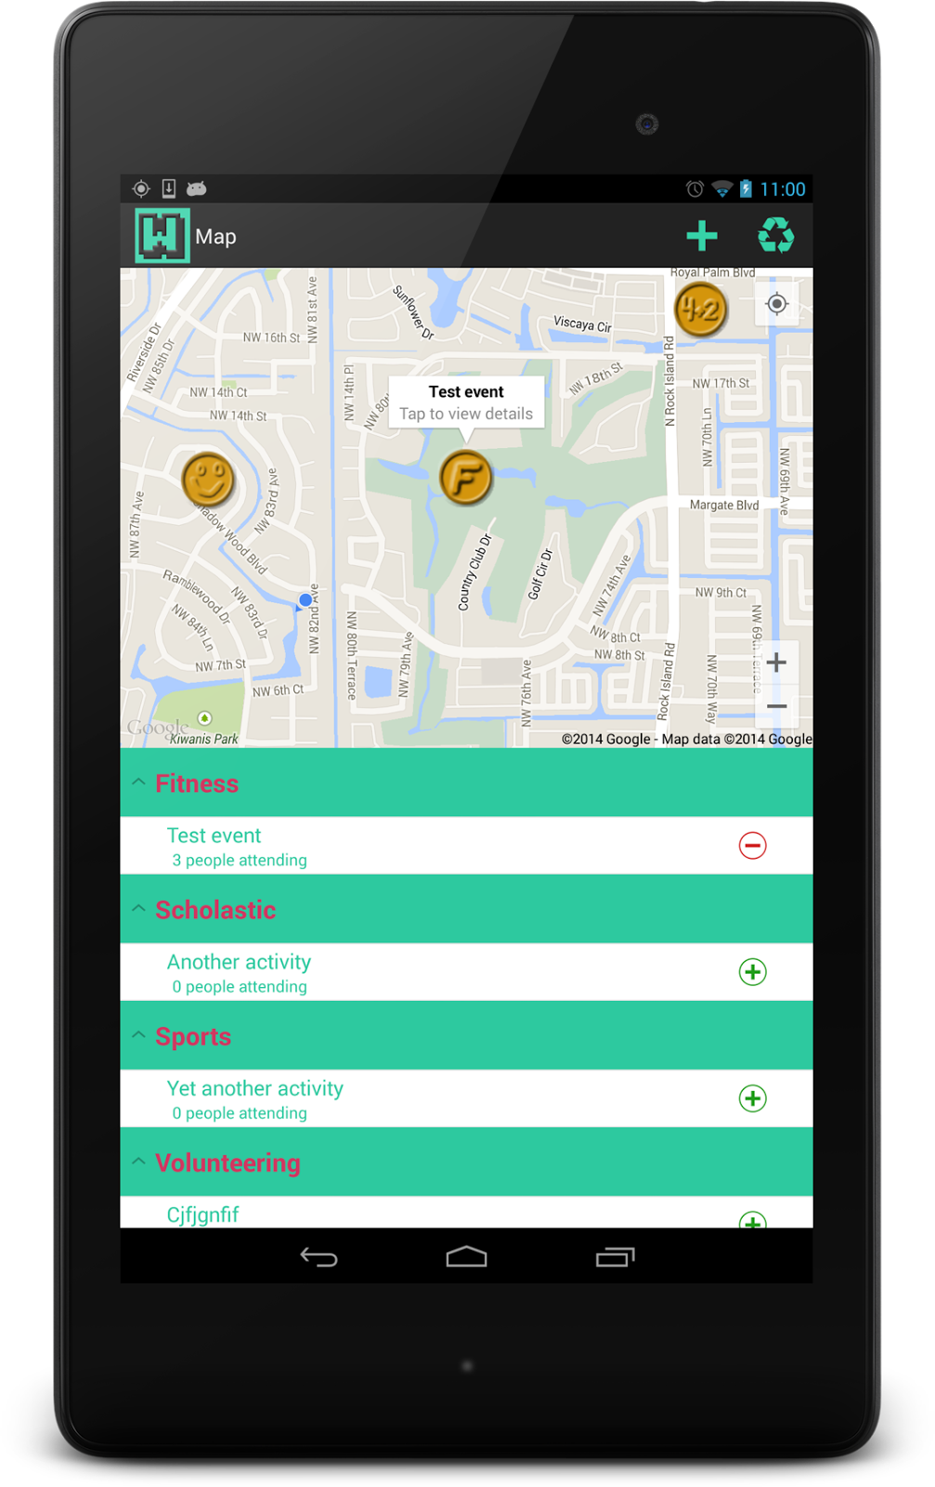

In addition, the reverse geocoding lookup finding an address from a given latitude and longitude is driven off the basis of having the current location, or the location of a given point in space.